

Faculty of Business Administration and Economics
Department Economics
Chair of Institutional Economics and Economic Policy

Bachelor Thesis
<Title>

Submitted to:
< First examiner >
< Second examiner >

Submission date:
XX.XX.20XX

Submitted by:
< First name Surname > Study programme: <…...>
< Street house no.> Registration number: <1234567>
< Zip code City > Email: <…….>

Table of Contents
List of Figures II
List of Tables III
List of Abbreviations IV
1 Introduction 1
2 Chapter title 2
2.1 Subchapter (1) 2
2.1.1 Subsubchapter (1) 2
2.1.2 Subsubchapter (2) 3
2.2 Subchapter (2) 3
3 Formal design 4
3.1 Font and page formatting 4
3.2 Structure 4
3.3 Lists 4
3.3.1 List of Figures and Tables 4
3.3.2 List of Abbreviations 6
4 Conclusion 7
Bibliography V
Appendix VI
Declaration of Authorship VII

The chair of Institutional Economics and Economic Policy does not guarantee for correctness and completeness of the given information and can hence not assume responsibility for any occurring problems (e.g. deadline defaults etc.)! It is advisable to continuously consult your supervisor during the editing of your academic paper.

List of Figures
Figure 1: Visualization of the SEIR model 4
Figure 2: Matching Markets 5

List of Tables
Table 1: Gegenüberstellung der Komplikationen nach Masernerkrankung 5
Table 2: Distribution of District Schools 5

List of Abbreviations
DA Deferred Acceptance Algorithm
GS Gale Shapley Algorithm
NRMP National Resident Matching Program
TTC Top Trading Cycles Algorithm

Introduction
The introduction should present the motivation of the work, make the research question clear and distinguish it from other questions, and explain the approach and the chosen structure of the work. The introduction is not divided into further subchapters such as "1.1 Approach" and "1.2 Outline of the thesis".

Chapter title
Lorem ipsum dolor sit amet, consetetur sadipscing elitr, sed diam nonumy eirmod tempor invidunt ut labore et dolore magna aliquyam erat, sed diam voluptua. At vero eos et accusam et justo duo dolores et ea rebum.

Subchapter (1)
Lorem ipsum dolor sit amet, consetetur sadipscing elitr, sed diam nonumy eirmod tempor invidunt ut labore et dolore magna aliquyam erat, sed diam voluptua. At vero eos et accusam et justo duo dolores et ea rebum. Stet clita kasd gubergren, no sea takimata sanctus est Lorem ipsum dolor sit amet. Lorem ipsum dolor sit amet, consetetur sadipscing elitr, sed diam nonumy eirmod tempor invidunt ut labore et dolore magna aliquyam erat, sed diam voluptua. At vero eos et accusam et justo duo dolores et ea rebum. Stet clita kasd gubergren, no sea takimata sanctus est Lorem ipsum dolor sit amet.

Subsubchapter (1)
Lorem ipsum dolor sit amet, consetetur sadipscing elitr, sed diam nonumy eirmod tempor invidunt ut labore et dolore magna aliquyam erat, sed diam voluptua. At vero eos et accusam et justo duo dolores et ea rebum. Stet clita kasd gubergren, no sea takimata sanctus est Lorem ipsum dolor sit amet. Lorem ipsum dolor sit amet, consetetur sadipscing elitr, sed diam nonumy eirmod tempor invidunt ut labore et dolore magna aliquyam erat, sed diam voluptua. At vero eos et accusam et justo duo dolores et ea rebum. Stet clita kasd gubergren, no sea takimata sanctus est Lorem ipsum dolor sit amet. Lorem ipsum dolor sit amet, consetetur sadipscing elitr, sed diam nonumy eirmod tempor invidunt ut labore et dolore magna aliquyam erat, sed diam voluptua. At vero eos et accusam et justo duo dolores et ea rebum. Stet clita kasd gubergren, no sea takimata sanctus est Lorem ipsum dolor sit amet. Lorem ipsum dolor sit amet, consetetur sadipscing elitr, sed diam nonumy eirmod tempor invidunt ut labore et dolore magna aliquyam erat, sed diam voluptua. At vero eos et accusam et justo duo dolores et ea rebum. Stet clita kasd gubergren, no sea takimata sanctus est Lorem ipsum dolor sit amet.

Subsubchapter (2)
Lorem ipsum dolor sit amet, consetetur sadipscing elitr, sed diam nonumy eirmod tempor invidunt ut labore et dolore magna aliquyam erat, sed diam voluptua. At vero eos et accusam et justo duo dolores et ea rebum. Stet clita kasd gubergren, no sea takimata sanctus est Lorem ipsum dolor sit amet. Lorem ipsum dolor sit amet, consetetur sadipscing elitr, sed diam nonumy eirmod tempor invidunt ut labore et dolore magna aliquyam erat, sed diam voluptua. At vero eos et accusam et justo duo dolores et ea rebum. Stet clita kasd gubergren, no sea takimata sanctus est Lorem ipsum dolor sit amet. Lorem ipsum dolor sit amet, consetetur sadipscing elitr, sed diam nonumy eirmod tempor invidunt ut labore et dolore magna aliquyam erat, sed diam voluptua. At vero eos et accusam et justo duo dolores et ea rebum. Stet clita kasd gubergren, no sea takimata sanctus est Lorem ipsum dolor sit amet. Lorem ipsum dolor sit amet, consetetur sadipscing elitr, sed diam nonumy eirmod tempor invidunt ut labore et dolore magna aliquyam erat, sed diam voluptua. At vero eos et accusam et justo duo dolores et ea rebum. Stet clita kasd gubergren, no sea takimata sanctus est Lorem ipsum dolor sit amet.

Subchapter (2)
Lorem ipsum dolor sit amet, consetetur sadipscing elitr, sed diam nonumy eirmod tempor invidunt ut labore et dolore magna aliquyam erat, sed diam voluptua. At vero eos et accusam et justo duo dolores et ea rebum. Stet clita kasd gubergren, no sea takimata sanctus est Lorem ipsum dolor sit amet. Lorem ipsum dolor sit amet, consetetur sadipscing elitr, sed diam nonumy eirmod tempor invidunt ut labore et dolore magna aliquyam erat, sed diam voluptua. At vero eos et accusam et justo duo dolores et ea rebum. Stet clita kasd gubergren, no sea takimata sanctus est Lorem ipsum dolor sit amet.

Formal design

Font and page formatting
Use a common font (e.g. Times New Roman or Arial). Leave a space of 2.5 cm on the left and right sides and at the top of the sheet. The bottom margin is 2 cm. Please use a 12 font and a line spacing of 1.5 lines for the normal text. For footnote text, use a 10 font and single line spacing. Pages should be numbered consecutively. Justification is desirable. Word separations should also be made.

Structure
The exact structure of a scientific paper can be found in the overview file "Techniques of scientific work". You can change the headings of the chapters, figure, and table headings etc. according to your ideas (color, size, italics, bold, ...). However, the formatting should be appropriate for a scientific paper.

Lists
The lists are located after the contents directory. As a general rule, only insert lists if they are needed. For example, if you do not use tables in your work, you do not need to create a list of tables. The following three lists are common types, but other lists such as a list of symbols are also possible.

List of Figures and Tables
Tables and figures have to be numbered consecutively and bear a heading (table header) with a clear statement of contents and the source at the foot of the table. Examples:

Figure 1: Visualization of the SEIR model
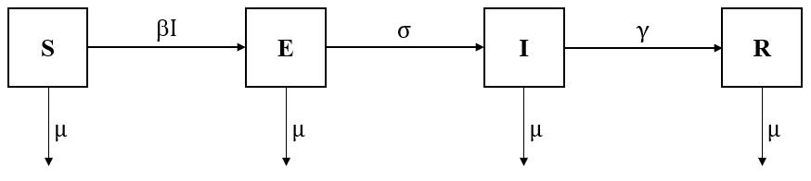
Source: own depiction following Bjørnstad (2005), p. 2.

Figure 2: Matching Markets
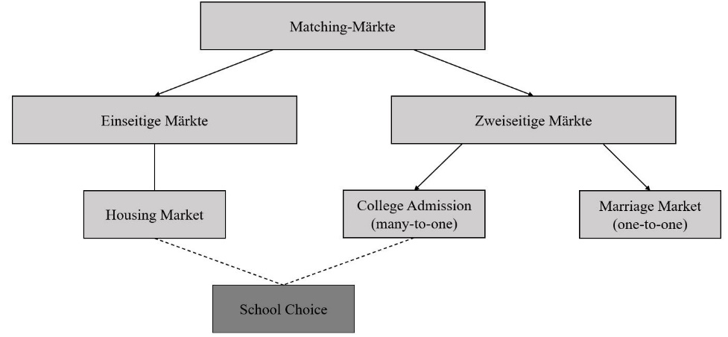
Source: Stroh-Maraun (2019), p. 8.

Table 1: Gegenüberstellung der Komplikationen nach Masernerkrankung
Erkrankung | Häufigkeit nach Maserninfektion | Letalität
Enzephalitis  (bei Jugendlichen & Erwachsenen)  (bei Säuglingen & Kleinkindern) | 1/250-500  1/1.0000 | 10-30 %
Exanthem | 98 % | *
Fieber | 98 % | *
Fieberkrämpfe (im Kleinkindesalter) | 8 % | *
subakute sklerosierende Panenzephalitis (SSPE) | 5-10/1.000.000 | 15 %
Thrombozytopenische Purpur  (Autoimmunerkrankung) | 1/6.000 | *
∗ Keine Werte in der Literatur vorhanden/gefunden
Source: Quast & Stück (2002), p. 3; Meyer & Reiter (2004), p. 1184; Alexander & Raettig (1987), p. 62.

Table 2: Distribution of District Schools
District School | A | B | C | D | E | F | G
Students | 1 - 3 | 4 - 6 | 7 - 12 | 13 - 18 | 19 - 24 | 25 - 30 | 31 - 36

Source: own depiction following Chen und Sönmez (2006), p. 9.

List of Abbreviations
The abbreviations are included in the list of abbreviations. The first time the word to be abbreviated is used, the abbreviation is placed in brackets after it in the text. Subsequently, the abbreviation can be used in the text. Frequently used words or words that are officially abbreviated, such as World Health Organization (WHO), are abbreviated.
Examples:
"In numerous experiments, the most widely used assignment mechanisms – the Deferred Acceptance Algorithm (DA), the Boston School Choice Algorithm (BOS), and the Top Trading Cycles Algorithm (TTC) – are examined for their theoretical properties as well as their performance."
"In the 1950s, the National Resident Matching Program (NRMP) was established as the central allocation agency to assign residents to hospitals."

Conclusion
The conclusion is the final chapter of the thesis. It summarizes the main results of the work and gives an outlook on further work on the topic.
/

Bibliography
These are examples of literature references according to the specifications of the review file "Techniques of Scientific Work":
Abdulkadi̇roğlu, A.; Pathak, P. A.; Roth, A. E.; & Sönmez, T. (2005): The Boston Public School Match. In: The American Economic Review, 95(2), 368-371.
Deutsche Stiftung Organtransplantation (2019): Jahresbericht: Organspende und Transplantation in Deutschland 2019 [online] https://www.dso.de/SiteCollectionDocuments/DSO-Jahresbericht%202019.pdf [02.07.2020].
Friedman, M. (1955): The Role of Government in Education. In: Solo, R. (Eds.), Economics and the Public Interest. New Brunswick.
Gabler Wirtschaftslexikon (2020): Algorithmus [online] https://wirtschaftslexikon.gabler.de/definition/algorithmus-27106 [06.06.2020].
Gale, D.; Shapley, L. S. (1962): College Admissions and the Stability of Marriage. In: American Mathematical Monthly, 69(1), 9-15.
Guillen, P.; Veszteg, R. F. (2019): Strategy-proofness in Experimental Matching Markets. Working Paper, WINPEC, Waseda University.
He, Y. (2017): Gaming the Boston School Choice Mechanism in Beijing. Technical report, Toulouse School of Economics.
Niederle, M.; Roth, A. E.; Sönmez, T. (2008): Matching and Market Design. In: Durlauf, S. N.; Blume, L. E. (Eds.), The New Palgrave Dictionary of Economics, 2. Edition, Volume 5. Cambridge: Palgrave Macmillan, 436-445.
Roth, A. E.; Sönmez, T.; Ünver, M. U. (2004): Kidney Exchange. In: Quarterly Journal of Economics, 119(2), 457-488.
Stroh-Maraun, N. (2019): Mechanisms, Preferences, and Heterogeneity in Matching Markets, Economic dissertations, Paderborn University.

Appendix
The appendix of the thesis contains less relevant, detailed information that are not important enough to be included in the main part of the work.

Declaration of Authorship
This is a template for a statutory declaration. Please cross out the statement regarding the storage of your work that is not applicable!
By submitting this thesis, I, <NAME>, confirm that I have prepared it independently and without unauthorized aids or unauthorized help from third parties. All passages that originate in content or verbatim from publications are marked as such. I further declare that I have marked as such (e.g. as direct quotations) all passages of the work that were originally created by text-creating software or were substantially influenced in their statement by such software. This assurance also includes all tables, sketches, drawings, pictorial representations and other elements contained in the work.
This thesis has not yet been submitted or has not been submitted in the same or a similar form to any examination authority and has not yet been published. I am aware that the work is stored electronically and can be checked for violations of this declaration with the help of software. I am also aware that if an incorrect declaration is submitted, the examination will be assessed as failed. Furthermore, the content of the thesis should not be made accessible to third parties without my express permission.

Paderborn, on ...

Signature of candidate

