Faculty of Business Administration and Economics
Chair of Organizational, Media and Sports Economics
_________________________________________________________________________

<Type of paper>
<Title of paper>
_________________________________________________________________________

submitted to:
Prof. Dr. Bernd Frick

supervised by:
<Mr/ Ms> <Title> <First name Last name>

due date:
<day> <month> <year>

submitted by:

<First name> <Last name> | Course of studies: <Course of studies>
<Street> <number> | Matriculation number: <### # ###>
<Postal code> <City> | Phone: <area code>/ <number>

Executive Summary (not necessary for seminar papers)
Text Text Text Text Text Text Text Text Text Text Text Text Text Text Text Text Text Text Text Text Text Text Text Text.

Table of Contents

List of figures II
List of tables III
List of abbreviations (terms should not be named in the dictionary) IV
1 Heading (Introduction and structure) 1
1.1 2nd order heading 1
1.2 2nd order heading 1
1.2.1 3rd order heading 1
1.2.2 3rd order heading 2
2 Heading (e.g. Theoretical background) 2
2.1 2nd order heading 2
2.2 2nd order heading 2
References V
Appendix VI
Statutory declaration VII

List of figures
Figure 1: Title of the figure 2

List of tables
Table 1: Title of the table 3

List of abbreviations (terms should not be named in the dictionary)
abbreviation written-out term
abbreviation written-out term
abbreviation written-out term

Heading (Introduction and structure)
At the chair of Organizational, Media and Sports Economics the American citation style is used (Harvard-system). Literally or by content citations do not need the prefixed „cf.“(confer). As a matter of principle, citations should refer to the original text. Example: Text Text Text Text Text Text Text Text Text Text Text Text (Author, year: page).

Direct citations however have to be marked with quotation marks. The source is named directly after the citation. Example: “Text Text Text Text Text Text” (Author, year: page).

Direct citations with a length of more than three lines will be additionally indented and displayed in font size 10. Example:
“Text Text Text Text Text Text Text Text Text Text Text Text Text Text Text Text Text Text Text Text Text Text Text Text Text Text Text Text Text Text Text Text Text Text Text Text Text Text Text Text Text Text Text Text Text Text Text Text Text Text Text Text Text Text Text Text Text Text“ (Author, year: page).

2nd order heading
Text Text Text Text Text Text Text Text Text Text Text Text Text Text Text Text Text Text Text Text Text Text Text Text Text Text Text Text Text Text Text Text Text Text Text Text Text Text Text.

2nd order heading
Text Text Text Text Text Text Text Text Text Text Text Text Text Text Text Text Text Text Text Text Text Text Text Text Text Text Text Text Text Text Text Text Text Text Text Text Text Text Text Text Text Text Text Text Text Text Text Text Text Text Text Text Text Text Text Text Text Text Text Text Text Text Text Text Text Text Text Text Text Text Text Text Text Text Text Text Text Text Text Text Text Text.

3rd order heading
Text Text Text Text Text Text Text Text Text Text Text Text Text Text Text Text Text Text Text Text.

3rd order heading
Text Text Text Text Text Text Text Text Text Text Text Text Text Text Text Text Text Text Text Text.

Heading (e.g. Theoretical background)
Text Text Text Text Text Text Text Text Text Text Text Text Text Text Text Text Text Text Text Text.

2nd order heading
Text Text Text Text Text Text Text Text Text Text Text Text Text Text Text Text Text Text Text Text.

2nd order heading
Text Text Text Text Text Text Text Text Text Text Text Text Text Text Text Text Text Text Text Text Text Text Text Text Text Text Text Text Text Text Text Text Text Text Text Text.
Figure 1: Title of the figure
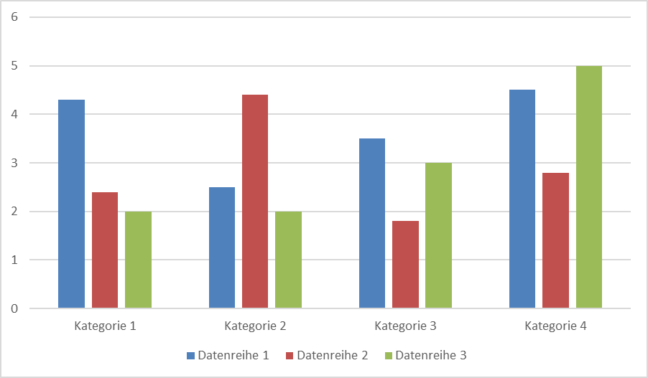
Source: Based on author, year: page.
Text Text Text Text Text Text Text Text Text Text Text Text Text Text Text Text Text Text Text Text Text Text Text Text Text Text Text Text Text Text Text Text Text Text Text Text Text Text Text Text Text Text Text Text Text Text Text Text Text Text Text Text Text Text Text Text Text Text Text Text Text Text Text Text Text Text Text Text Text Text Text Text.
Table 1: Title of the table
Variable | OLS-Modell | Fixed-Effects-Modell
Soziodemographische Variablen
Migrationshintergrund | -0,0168 | -0,0368
Alter | -0,119 | -0,187
Alter² | -0,222 | -0,115
Geschlecht | 0,135*** | 0,184***
Hauptschulabschluss | -0,125*** | -0,189***
Realschulabschluss | -0,0295 | -0,0344
Abitur | -0,0927* | -0,129*
Industrievariablen
Automobil | 0,833*** | 1,484***
Telekommunikation | 0,0877*** | 0,124***
Dienstleistungen | 0,830*** | 1,213***
Produzierendes Gewerbe | 0,349* | 0,556*
Landwirtschaft | 0,0751 | 0,103
Institutionelle Variablen
Betriebsrat | 0,768*** | 1,314***
Tarifvertrag | 0,0674*** | 0,0975***
Konstante | 0,276 | -----
R² | 0,2154 | -----
Root MSE | 0,70606 | -----
N | 3220 | 3220
Levels of statistical significance are defined as follows: * p<0,1; **p<0,05; *** p<0,01
Source: Based on author, year: page.
Text Text Text Text Text Text Text Text Text Text Text Text Text Text Text Text Text Text.

References
Bassanini, A., Booth, A. L., Brunello, G., De Paola, M., & Leuven, E. 2007. Workplace Training in Europe. In G. Brunello, P. Garibaldi & E. Wasmer (Eds.), Education and training in Europe: 143–323. Oxford: Oxford University Press.
Bundesgesetz über eine nachhaltige Abfallwirtschaft (Abfallwirtschaftsgesetz 2002 – AWG 2002) [BGBl. I Nr. 102] zuletzt geändert durch das Bundesgesetz [BGBl. I Nr. 54/2008].
Cunha, F., & Heckman, J. J. 2007a. The Technology of Skill Formation. American Economic Review, 97(2): 31–47.
Cunha, F., & Heckman, J. J. 2007b. The Evolution of Inequality, Heterogeneity and Uncertainty in Labor Earnings in the U.S. Economy. IZA Diskussionspapier Nr. 3115.
Hofstede, G. 1993. Interkulturelle Zusammenarbeit: Kulturen, Organisationen, Management. Wiesbaden: Gabler.
Kreft, I., & Leeuw, J. d. 2007. Introducing Multilevel Modeling. London [u.a.]: Sage.
o.V. (2007): Zu einer besseren Umweltbilanz. Der Standard (Wien), 13.08.2007: 9.
Thimme, Paul 2001: Potenziale betrieblichen Umweltschutzes in Entwicklungsländern am Beispiel Zimbabwes.

Appendix

Statutory declaration
I hereby affirm that I, First and last name, have authored this thesis independently, that I have not used other than the declared sources, and that I have explicitly marked all material which has been quoted either literally or by content from the used sources.
This thesis has not been submitted or published either in whole or part, for a degree at this or any other university or institution.

City, Date Signature

Footnotes are to be used sparingly. They elaborate further aspects or show a great number of further sources which would hinder the flow of reading. Footnotes are placed on the bottom of the respective page. They are numbered continuously. The font size is 10. A footnote ends with a period/full stop.

