 | Faculty of Business Administration and Economics  Chair of Sustainable Human Resource  Management and Leadership

<Type of paper>

<Title of paper>

submitted to:

Prof. Dr. Philip Yang

Bachelor/Master thesis as part of the
(state your full degree) degree at Paderborn University

<First name> <Last name> | Supervisor 1: Prof. Dr. Philip Yang
<Street> <number> <Postal code> <City> | Supervisor 2: <Name of supervisor 2>
Matriculation number: <#######> | Submitted on: <Date of submission>

Abstract
Your thesis should include an abstract as it is common practice in published journals as well. The abstract should be about half a page long and briefly state your topic, hypotheses, methodology, results, and implications.

Table of Contents

List of figures II
List of tables III
List of abbreviations (terms should not be named in the dictionary) IV
1 Heading (Introduction and structure) 1
1.1 2nd order heading 1
1.2 2nd order heading 1
1.2.1 3rd order heading 2
1.2.2 3rd order heading 2
2 Heading (e.g. Theoretical background) 2
2.1 Including figures created by you 2
2.2 Including adapted figures 2
2.3 Including original figures 3
2.4 Including a table 3
References V
Affirmation of the independent preparation of the thesis VI

List of figures
Figure 1: Exemplary model 2
Figure 2: Example of adapted figure 3
Figure 3: Theoretical model 3

List of tables
Table 1: Exemplary table 4

List of abbreviations (terms should not be named in the dictionary)
abbreviation written-out term
abbreviation written-out term
abbreviation written-out term
LMX Leadership-Member Exchange
SDG Sustainable Development Goals
SHRM Sustainable Human Resource Management

Heading (e.g. Introduction and structure)
We use the American Psychological Association (APA) citation style at the chair of Sustainable Human Resources Management & Leadership. In the case of indirect quotations, the source is indicated at the end of the sentence or after the paraphrased content. As a matter of principle, citations should refer to the original text. Example 1: Text Text text text text text text text text text text text (Author, year). Example 2: Text text text text (Author1, year), text text text text text text (Author2, year). You only need to include the page number in the reference if you use direct citations. Indirect citations and paraphrases neither need a reference to a page nor do they need the prefix of “c.f.”. A guide on how to cite any source including webpages can be found on the APA Style website (APA Style, 2021).
Direct citations must be marked with quotation marks. The source is named directly after the citation. Example: “Text text text text text text” (Author, year, page).
Direct citations with a length of more than three lines will be additionally indented and displayed in font size 10.
Example:
„ Lorem ipsum dolor sit amet, consetetur sadipscing elitr, sed diam nonumy eirmod tempor invidunt ut labore et dolore magna aliquyam erat, sed diam voluptua. At vero eos et accusam et justo duo dolores et ea rebum. Stet clita kasd gubergren, no sea takimata sanctus est Lorem ipsum dolor sit amet. “ (Author, year, page).
Please make sure that the references only contain sources that have been used in the text. For example, Sonnentag and Frese (2003) can now be used in the references. If this sentence was not in the text, Sonnentag and Frese (2003) should not be listed in the references.

2nd order heading
Lorem ipsum dolor sit amet, consetetur sadipscing elitr, sed diam nonumy eirmod tempor invidunt ut labore et dolore magna aliquyam erat, sed diam voluptua. At vero eos et accusam et justo duo dolores et ea rebum. Stet clita kasd gubergren, no sea takimata sanctus est Lorem ipsum dolor sit amet.

2nd order heading
Nam liber tempor cum soluta nobis eleifend option congue nihil imperdiet doming id quod mazim placerat facer possim assum. Lorem ipsum dolor sit amet, consectetuer adipiscing elit, sed diam nonummy nibh euismod tincidunt ut laoreet dolore magna aliquam erat volutpat. Ut wisi enim ad minim veniam, quis nostrud exerci tation ullamcorper suscipit lobortis nisl ut aliquip ex ea commodo

3rd order heading
Please make sure to always add at least two headings when you add a 2nd and/or 3rd order heading. For example, there should not be chapter 1.2.1 if there is no chapter 1.2.2. In the same way, there should only be chapter 1.2.1.1 if there is also chapter 1.2.1.2.

3rd order heading
Ut wisi enim ad minim veniam, quis nostrud exerci tation ullamcorper suscipit lobortis nisl ut aliquip ex ea commodo consequat. Duis autem vel eum iriure dolor in hendrerit in vulputate velit esse molestie consequat, vel illum dolore eu feugiat nulla facilisis at vero eros et accumsan et iusto odio dignissim qui blandit praesent luptatum zzril delenit augue duis dolore te feugait nulla facilisi.

Heading (e.g. Theoretical background)
In this section, we explain to three options how to include a figure in your text. Essentially, the main difference between the options lies in how you label the source of the figure. The same labelling format applies to the inclusion of tables. We have provided some examples below. Please make sure to refer to the respective figure or table somewhere in the text

Including figures created by you
If you have created your own figure and you want to include it in your text, please use the following format to label the source of the figure: “Source: Created by author”.
Duis autem vel eum iriure dolor in hendrerit in vulputate velit esse molestie consequat, vel illum dolore eu feugiat nulla facilisis at vero eros et accumsan et iusto odio dignissim qui blandit praesent luptatum zzril delenit augue duis dolore te feugait nulla facilisi.
Figure 1: Exemplary model
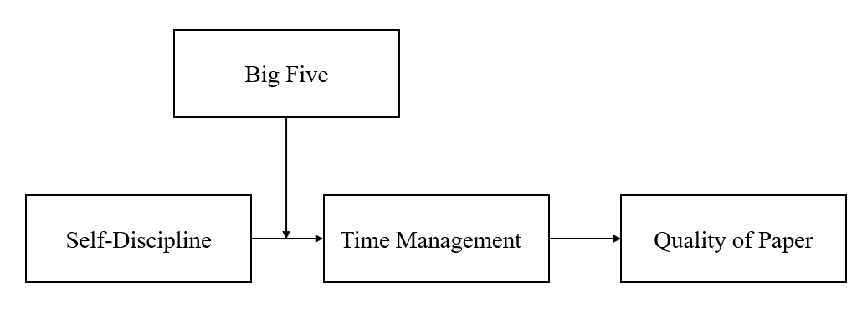
Source: Created by author.

Including adapted figures
If you want to include a figure that is based on a figure that already exists, please use the format below to refer to the source of the figure. The format of the source is “Adapted from <author(s)> <(year)>, <page>.
Figure 2: Example of adapted figure
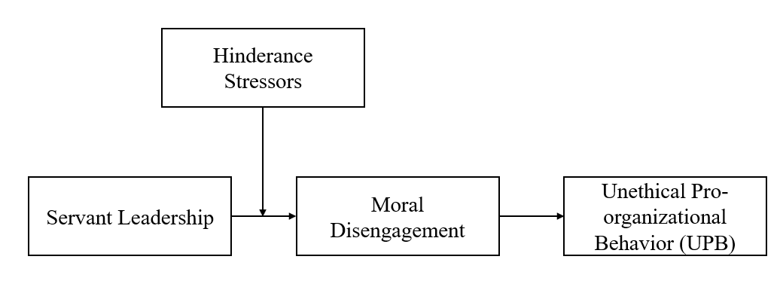
Source: Created by author adapted from Dennerlein & Kirkman (2022).

Including original figures
If you want to include an original figure, please use the format below to refer to the source of the figure. The format of the source is “Retrieved from <author(s)> <(year)>, <page>.
Figure 3: Theoretical model
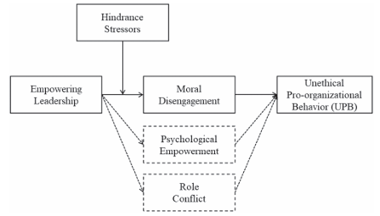
Source: Dennerlein & Kirkman (2022), p. 2.
Lorem ipsum dolor sit amet, consetetur sadipscing elitr, sed diam nonumy eirmod tempor invidunt ut labore et dolore magna aliquyam erat, sed diam voluptua. At vero eos et accusam et justo duo dolores et ea rebum. Stet clita kasd gubergren, no sea takimata sanctus est Lorem ipsum dolor sit amet. Lorem ipsum dolor sit amet, consetetur sadipscing elitr, sed diam nonumy eirmod tempor invidunt ut labore et dolore magna aliquyam erat, sed diam voluptua. At vero eos et accusam et justo duo dolores et ea rebum. Stet clita kasd gubergren, no sea takimata sanctus est Lorem ipsum dolor sit amet. Lorem ipsum dolor sit amet, consetetur sadipscing elitr, sed diam nonumy eirmod tempor invidunt ut labore et dolore magna aliquyam erat, sed diam voluptua. At vero eos et accusam et justo duo dolores et ea rebum. Stet clita kasd gubergren, no sea takimata sanctus est Lorem ipsum dolor sit amet.

Duis autem vel eum iriure dolor in hendrerit in vulputate velit esse molestie consequat, vel illum dolore eu feugiat nulla facilisis at vero eros et accumsan et iusto odio dignissim qui blandit praesent luptatum zzril delenit augue duis dolore te feugait nulla facilisi. Lorem ipsum dolor sit amet, consectetuer adipiscing elit, sed diam nonummy nibh euismod tincidunt ut laoreet dolore magna aliquam erat volutpat.

Ut wisi enim ad minim veniam, quis nostrud exerci tation ullamcorper suscipit lobortis nisl ut aliquip ex ea commodo consequat. Duis autem vel eum iriure dolor in hendrerit in vulputate velit esse molestie consequat, vel illum dolore eu feugiat nulla facilisis at vero eros et accumsan et iusto odio dignissim qui blandit praesent luptatum zzril delenit augue duis dolore te feugait nulla facilisi.

Including a table
Including a table follows a similar procedure as the inclusion of a figure. Please refer to the guidelines on how to cite a figure when citing a table. They apply for figures and tables alike.
Table 1: Exemplary table
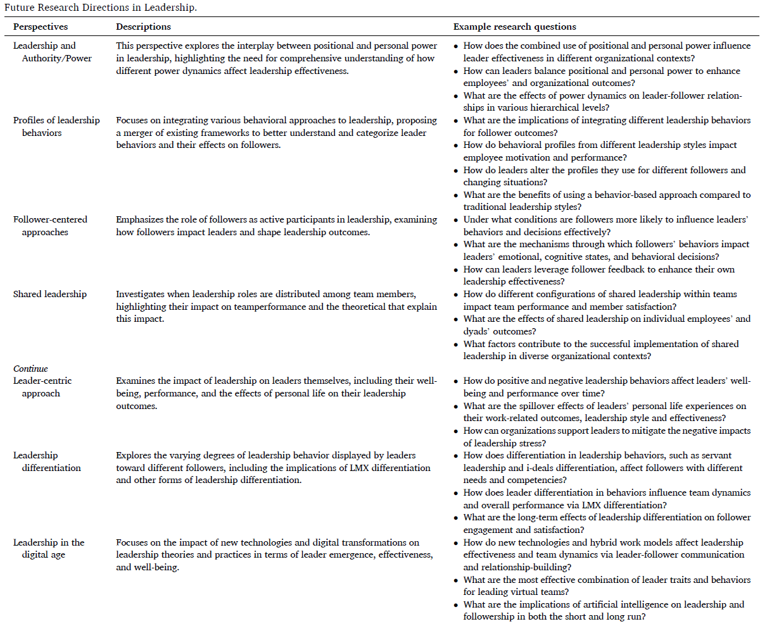
Source: Liden et al. (2025), p. 8.
At vero eos et accusam et justo duo dolores et ea rebum. Stet clita kasd gubergren, no sea takimata sanctus est Lorem ipsum dolor sit amet. Lorem ipsum dolor sit amet, consetetur sadipscing elitr, sed diam nonumy eirmod tempor invidunt ut labore et dolore magna aliquyam erat, sed diam voluptua. At vero eos et accusam et justo duo dolores et ea rebum. Stet clita kasd gubergren, no sea takimata sanctus est Lorem ipsum dolor sit amet. Lorem ipsum dolor sit amet, consetetur sadipscing elitr, At accusam aliquyam diam diam dolore dolores duo eirmod eos erat, et nonumy sed tempor et et invidunt justo labore Stet clita ea et gubergren, kasd magna no rebum. sanctus sea sed takimata ut vero voluptua. est Lorem ipsum dolor sit amet. Lorem ipsum dolor sit amet, consetetur.

References
APA Style. (2021, October). Webpage on a Website References. https://apastyle.apa.org/style-grammar-guidelines/references/examples/webpage-website-references
Cicero. (45 BC). De finibus bonorum et malorum Lorem ipsum. Retrieved December 9, 2024,
from https://www.loremipsum.de/
Dennerlein, T., & Kirkman, B. L. (2022). The hidden dark side of empowering leadership: The moderating role of hindrance stressors in explaining when empowering employees can promote moral disengagement and unethical pro-organizational behavior. Journal of Applied Psychology, 107(12), 1-23. http://doi.org/10.1037/apl0001013
Liden, R. C., Wang, X., & Wang, Y. (2025). The evolution of leadership: Past insights, present
trends, and future directions. Journal of Business Research, 186, 115036.
https://doi.org/10.1016/j.jbusres.2024.115036
Sonnentag, S., & Frese, M. (2003). Stress in organizations. In W. C. Borman, D. R. Ilgen, & R. J. Klimoski (Eds.), Handbook of Psychology (pp. 453 491). Wiley. https://doi.org/10.1002/0471264385.wei1218

Affirmation of the independent preparation of the thesis
I hereby affirm that I, >First and last name<, have authored this thesis independently, that I have not used other than the declared sources, and that I have explicitly marked all material which has been quoted either literally or by content from the used sources.
This thesis has not been submitted or published either in whole or part, for a degree at this or any other university or institution.

Place, Date |  | Signature

Footnotes are to be used sparingly. They elaborate further aspects or show a great number of further sources which would hinder the flow of reading. Footnotes are placed on the bottom of the respective page. They are numbered continuously. The font size is 10. A footnote ends with a period/full stop.

